

MATHEMATICS
Methods Units 1 & 2

Test 1 – Trigonometry

Chapters 11, 12 and 13
Semester 1 2019

Section Two - Calculator Assumed

Time allowed for this section
Working time for this section: 30 minutes
Marks available: 31 marks

Material required/recommended for this section

To be provided by the supervisor
This Question/Answer booklet
Formula sheet

To be provided by the candidate
Standard items: pens, pencils, pencil sharpener, eraser, correction fluid, ruler, highlighters

Special items: drawing instruments, templates, notes on one unfolded sheet of A4 paper, and up to three calculators satisfying the conditions set by the Curriculum Council for this course.

Important note to candidates
No other items may be used in this section of the examination. It is your responsibility to ensure that you do not have any unauthorised notes or other items of a non-personal nature in the examination room. If you have any unauthorised material with you, hand it to the supervisor before reading any further.

- (6 marks)
Evaluate x correct to one decimal place.
- 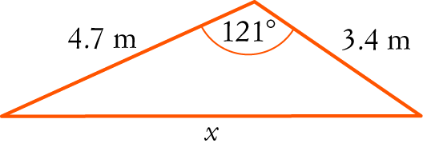 [3]

- 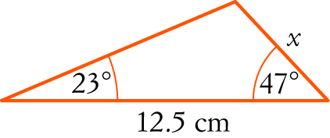 [3]

- (3 marks)
Calculate the smallest possible length of AB in the triangle shown below.
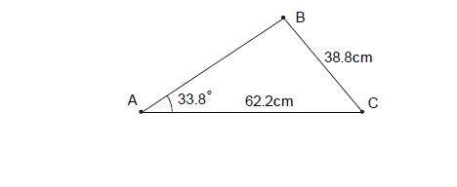
(The triangle is not drawn to scale).

- (9 marks)
Two circles, one of radius 8cm and the other of radius 18cm, with a common tangent, touch each other as shown in the diagram.
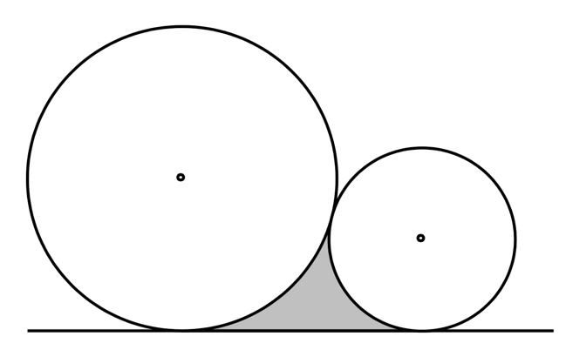

- Calculate the perimeter of the shaded region. [5]

- Calculate the area of the shaded region. [4]

- (3 marks)
In the diagram below (not to scale), the line AC intersects the line BD at O. The angle AOB=35º, and the lengths OB=14cm, OD=26cm and AC=30cm. If the area of triangle ODC is twice that of triangle OAB, determine the length OA.
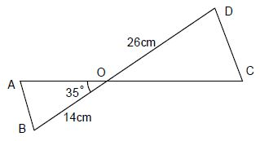

- (4 marks)
In the quadrilateral ABCD, AB = 6cm, BC = 7cm, AD = 12cm, and ABC = 120°, angle ACD = 70°. Calculate the size of angle ADC. Give your answer to 2 decimals.
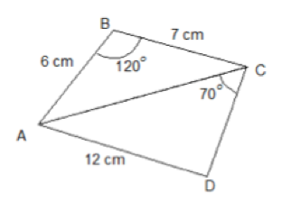

- (3 marks)
The diagram shows a sector of a circle with centre O. The radius of the circle is 8 cm. PRS is an arc of the circle. PS is a chord of the circle. Angle POS = radians
Calculate the area of the shaded segment. Give your answer correct to 3 significant figures.

- (3 marks)
The diagram shows a sector of a circle with centre O. The radius of the circle is 6 cm and angle AOB = 120°. Find the arc length AB in terms of π.

End of Test

